**Timeframe Selection** & **Defining Setups**

Daily chart is the best chart

A model is applicable to every timeframe

Choose a model you can spot easily, that you like the most

Timeframe Selection & Defining Setups For Your Model

Timeframe Selection

Monthly Charts - Position Trading. Weekly Charts - Swing Trading.

Daily Charts - Short Term Trading. 4 Hour or Less - Day Trading.

Defining Setups For Your Model.

Trend Trader: Trading only in the direction of the Monthly & Weekly Chart direction. Swing Trader: Trading the Daily Chart intermediate term price action.

Contrarian Trader: Trading reversal patterns at market extremes. Short Term Trader: Trading the weekly ranges for 1-5 days in duration.

Day Trader: lntraday swing trading with exits by 2:00 pm New York time.

Its about your unique personality

As a beginner, start with the daily chart Daily chart gives you your daily bias But the hard part is trusting it

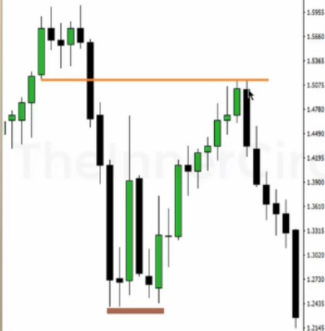Look for markets that show a strong willingness to move away from a spot Monthly chart is a lot of money behind it so its important to know the monthly chart Smart money sells in upmoves and buys in downmoves

|  |  |  |  |  |  |
| --- | --- | --- | --- | --- | --- |
|  | I! | | The Long term Price Action reference lor | |  |
| the lo1gesl Price 1'ction Swings in trading. | |
| It'' | **,a-, ----,,i-n--r** •,_  ltt •I •-  T I  11 I t ••  1• !J • ,..._  iI1I1l1 ••  **T** ::  1 | | T,Qd;ng ,e!vp, tokeo g,eol ot l;me lo form on thtS timelrome bvl when they  unfold - tney lend to unfold over mony  monlt.. |
|  | Due to the length of lime Ihis chort  requires to present o setup. trading in the |
|  | d;-ection of the most recent setup con yield **low** mk & t,;gh **cewo,d** condUion,. |
|  | Swings con be sevefol hundreds of pips. |
|  | Ove< o **long** t;me pe,iod. |

|  |  |  |  |  |
| --- | --- | --- | --- | --- |
|  |  |  | The Long term Price Action reference for the lor{ilesl Price Action Swings in trading.  Trading setups toke o great of lime to form on this timelrome but when they unfold - they tend to unfold over many months.  Due to the length of lime this chart  ,equireslo present o setup, !roding in the  direction of the most recent setup con yield low risk & high reward conditions. | |
| Swings can be several hundreds of pips. Over a long time period. |  |

Large funds have stops below that low

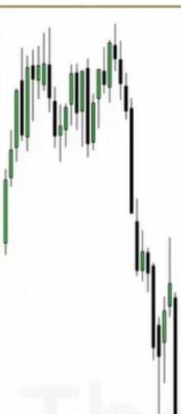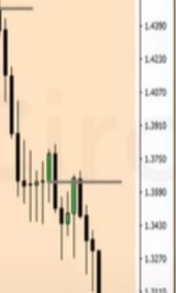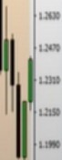

1

1111 1

A/ L,I, *I"'* ,..,,.+

The Intermediate term Price Action reference for the intermediate Price Action Swings in trading.

Trading setups take a some time to form on this timeframe but when they unfold - they tend to unfold over many weeks.

I lj

j1'

Due to the length of time this chart requires to present a setup, trading in the direction of the most recent setup can yield low risk & high reward conditions.

Swings can be several hundreds of pips.

Over a intermediate term time period.

He uses that breaker because its lower then the other one

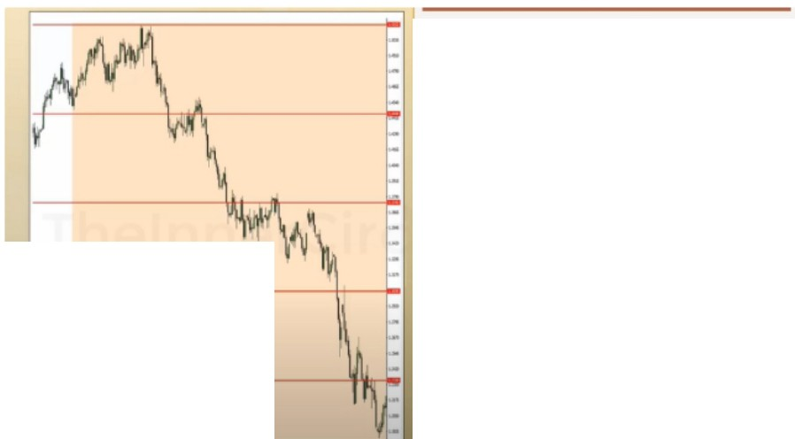

|  |  |  |  |
| --- | --- | --- | --- |
|  |  | The short term Price Action reference for  the short te,m Price Action Swings in  !roding.  Trading setups toke o Witte time to form on this limetrome but when they unfold - they tend lo unfold over 1-3 weeks.  Due lo the length of lime this chart requires to present a setup, trading In the direction of the most recent setup con yield low risk & high reword conditions. | |
| Swings con be 50 - 300 hundfed of pips. Over a short fem, lime period |  |

|  |  |  |
| --- | --- | --- |
|  | | D  The short term Price Action ,eference !Of  the short term Price Action Swings in  !roding.  Trading setups toke o little time to form on this limefrome bl.It when they unfold - they tend lo unfold over 1-3 weeks.  Due to the length of lime this chart requires to present a setup. trading in the direction of the most recent selup con yield low risk & high reword conditions.  Swings con be 50 • 300 hundred of pips. Over o shorl lerm lime period. |
|  |  |
|  | Grading Swings |

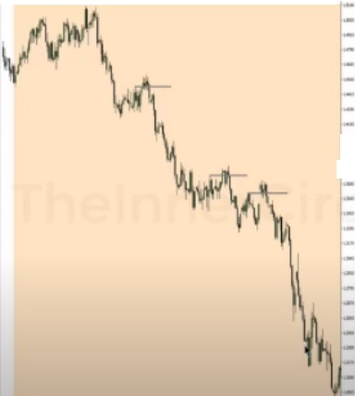At the grading swings setups should form, every 25% of the range

|  |  |  |
| --- | --- | --- |
|  |  | The short term Price Action reference for |
|  | the shorl lefm Price Action Swings in |
|  | trading. |
| - | lroding setups toke o 6ttte time to form on |
| - | this timefrome but when they unfold - |
| I- | they tend lo unfold over 1-3 weeks. |
|  | Due to the length of lime this chart |
|  | ,equires to present o setup. !roding in the |
|  | direction of !he most recent setup con |
|  | yiekl low risk & high reword conditions. |
|  | Swings con be 50- 300 hundred of pips. |
|  | Over a short lerm time period. |

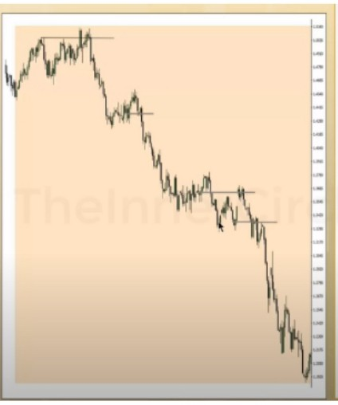

The short lerm Price Action reference ror the short term Price Action Swings in trading.

Trading setups toke a little time to form on this timelrome but when they unfold - Ihey tend to unfold over 1-3 weeks.

Due to the length ol lime lhischart requires lo present o setup. trading in the direction ol the most recent setup con yiek:l low risk & high reword conditions.

Swings con be 50 - 300 hundred of pips. Over o short term l'ime period.

We look at OTEs, orderblocks, stop runs (turtle soup, false breakout), breakerblocks They absorb orders on the buyside and then quickly move to the downside

We look for these flase breakouts when we know price will likely be bearish, we can anticipate on them

First you have to know why the stop run is happening, and you get that context from in this case the monthly chart

Hold on to the bias until youre clearly shown your wrong, until it does that we stay with the mindset of going short

You only need 1 good pattern

ICT has 3, trades inside a range he waits for the pullback, or selling at bearish orderblock, or he sells short at a sweep of buy stops. Trading inside the range, selling above a high or selling at an orderblock when he thinks its not necessary to run the stops, adn you will learn that later to know when it will run a orderblock or if it will hold

Orderblocks Stop runs Liquidity voids

The only 3 patterns ICT trades

Youll have anything you need to know how to trade any market profile

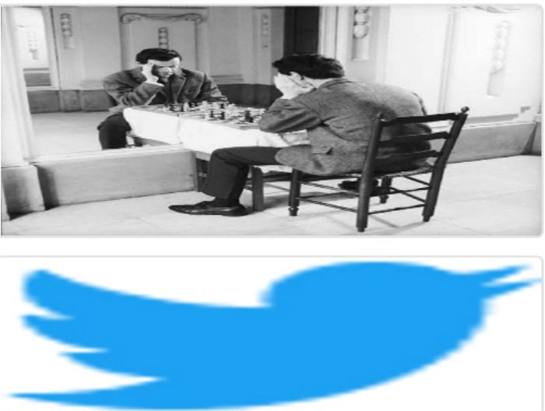Arjo I Twitter, lnstagram I Linktree

Linktree. Make your link do more.

I https://1.co/HhmmTN1fUI

JavaScript is not available.

"'# https://twitter.com/arjoio